1. **Project Title and Team Members**

**Title: SEMI-SUPERVISED AND SUPERVISED LEARNING METHODS FOR DETECTING FAKE ONLINE REVIEWS**

**Team Members:**

* Rohitha Nagineni(rohithanagineni@my.unt.edu)
* Sanjana Dadi(sanjanadadi@my.unt.edu)
* Monish Galla(monishgalla@my.unt.edu)
* Shiva Sai Amaravadi(shivasaiamaravadi@my.unt.edu)

1. **Goals and Objectives:**

**Motivation:**

As a result of technology's quick development, more advanced versions of earlier technologies become outdated. Individuals may now accomplish activities more quickly and effectively thanks to modern technologies, with internet markets being one notable breakthrough. It has become normal to use online platforms for bookings and purchasing, which emphasizes the necessity for strong assessment systems. The rising use of internet reviews as a helpful resource is the driving force for this study. But the threat posed by the abundance of phony reviews has prompted research into sophisticated methods for separating the real from the fake.

**Significance:**

In today's digital environment, internet reviews are crucial in determining how companies are perceived and how their marketing tactics are implemented. This study is important because it addresses the growing worry about fake online reviews. The credibility of online marketplaces is impacted, and the trust of real consumers is eroded by fraudulent reviews that are placed with the intention of promoting particular products. The study recognizes the need of creating efficient strategies to spot and block fake reviews, which will ultimately support the legitimacy and dependability of online feedback platforms.

**Objective:**

The main goal of this research is to improve the detection of phony internet reviews by using sophisticated classification techniques. To enhance classification performance, the research uses the Statistical Naive Bayes classifier and Support Vector Machines (SVM) in conjunction with the Expectation-maximization technique for semi-supervised learning. With consideration for elements like word frequency count, emotion polarity, review time, and user-specific information, the focus is on both the substance and the behaviour of the user. By combining content-based and user behaviour-based methods, the research seeks to provide fresh insights into the identification of fraudulent reviews.

**Features:**

To identify real and fraudulent online reviews, the research considers a number of features in an effort to develop strong classification techniques. These characteristics, which speak to the content of the reviews, include word frequency count, emotion polarity, and review length. Aspects of user behaviour are also considered, such the nationality, IP address, and posting frequency of the reviewer. Fraudulent review detection is made more accurate and efficient by using a combination of supervised and semi-supervised learning models, such as Support Vector Machines and Statistical Naive Bayes classifiers.

**Increment-1**

* **Related Work (Background):**

People write unworthy positive reviews of things to promote them. Sometimes people leave negative evaluations for other products with the goal of defaming them. Some of them are just non-reviews with no analysis of the products. People make contradictory claims to infer the nature of the opinions. Opinions on the product could run the gamut from positive to negative.

It gets far more difficult to spot reviews that are fake or designed to influence readers' perceptions after all these challenges. Since consumers these days rely so highly on opinions and reviews, identifying opinion spam or fraudulent reviews is a big problem for e-commerce websites and other service providers.

Revisiting Semi-Supervised Learning for Online Deceptive Review Detection

AUTHORS: J. K. Rout, A. Dalmia, and K.-K. R. Choo

ABSTRACT:

Since an increasing number of consumers utilize opinion evaluations to inform their service decisions, opinion reviews have a financial impact on businesses' bottom lines. It should not be shocking that malicious people or groups have attempted to use or manipulate online opinion reviews (like spam reviews) for financial gain or other purposes, and that identifying fake and misleading opinion reviews is an area of ongoing research interest. In this work, we first present a strategy for semi-supervised learning-based spam review identification, and then we demonstrate its use on a hotel review data set.

Detecting product review spammers using rating behaviors

AUTHORS: E. P. Lim, V.-A. Nguyen, N. Jindal, B. Liu, and H. W. Lauw

ABSTRACT:

This study aims to identify individuals who generate spam reviews or who engage in review spamming. We observe various differentiating traits and model them to detect review spammers. More specifically, we want to imitate the following behaviors. First, spammers could concentrate on specific products or product categories to maximize their efforts. Second, they frequently rate their products differently from other reviews. We evaluate our scoring methods on a dataset of Amazon reviews, providing a way to quantify each reviewer's spam level. Subsequently, we select a group of very dubious reviewers for our user evaluators to investigate further utilizing a web-based spammer evaluation tool created especially for user evaluation trials.

* Dataset:

Dataset is provided in GitHub link:

<https://github.com/Rohithanagineni/Semi-supervised-and-supervised-learning-methods-for-detecting-fake-online-reviews>

Video link :

<https://drive.google.com/file/d/19DV5BQ4_Zzrw8uC3jB2TnlbJXJpt1tAg/view?usp=sharing>

* **Detail Design of Methods:**

**System Architecture:**

System architecture is the conceptual model that explains the behavior, composition, and other elements of a system. An architectural description is a formal description and representation of a system that is organized to make it easier to draw conclusions about its structures and behaviors.A diagram of a machine learning process
Figure: System Architecture

**System Components:**

1. **Input:** Using this module, we will upload the Gold Standard Reviews dataset to the software.
2. **Splitting the data:** Preprocess Dataset: All the reviews will be scanned by this module, which will also tokenize them, remove stop words and special characters, and provide clean text. Clean text will be converted into a numeric vector called the TF-IDF (Term Frequency – Inverse Document Frequency) vector.
3. **Training the data using classifiers:** Run the software to find the prediction accuracy after training the model with the TF-IDF vector using the EM-SVM approach. Eighty percent of the dataset was used to train the model, while twenty percent was used to evaluate the approach.

**Run EM-Naive Bayes Algorithm**: use a trained dataset and the EM-Naïve Bayes method.

**Run SVM Algorithm:** trained dataset is used in the supervised SVM algorithm.

**Comparison Graph**: The accuracy of each method is compared in this graph.

1. **Output:** submit Test Review & forecast False & Sentiment: This module enables us to provide test data, after which the software predicts the sentiment of the review, including its falsity or truthfulness.

**Data Flow Diagram:**

1. The DFD is also known as a bubble chart. This simple graphical formalism can be used to depict a system in terms of the input data it receives, the many operations it performs on that data, and the output data it produces.
2. The data flow diagram is one of the most important modelling tools (DFD). It is used to model the system's constituent parts. These components include how the system operates, the data it utilizes, a third party that interacts with it, and the information that moves through it. DFD illustrates the flow of information through the system and the many changes that alter it. This method uses graphics to show how information flows and the changes made to data as it goes from input to output.
3. DFD shows how information moves through the system and the various modifications that make it different. This approach makes use of images to demonstrate the flow of information and the modifications made to data along the input-to-output process.

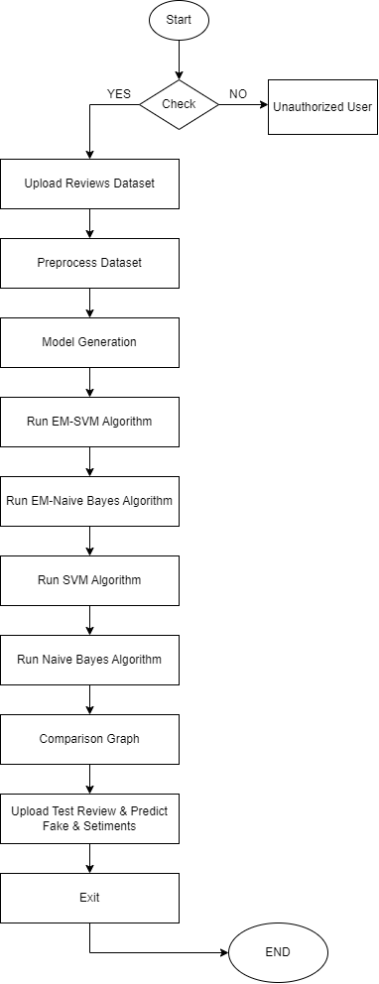

Figure: Data Flow Diagram

**UML Diagrams:**

UML stands for Unified Modelling Language. UML is a general-purpose modelling language

that is widely used in object-oriented software engineering. The standard was created and is

overseen by the Object Management Group.

The goal is for object-oriented software modelling to become more widely done using UML as a standard language. The notation and the meta-model are the two primary components of UML as it now stands. Other procedures or techniques that are related to UML might be added in the future.

The Unified Modelling Language is a single language used for describing, visualizing, creating, and documenting software system artefacts as well as for business modelling and other non-software systems.

The UML is a collection of advanced engineering methods that have been effectively applied to the modelling of complex and substantial.

**GOALS:**

The primary goals of the UML design are as follows:

* Why Provide users with an expressive, user-friendly visual modelling language so they can produce and distribute useful models.
* Provide techniques for specialization and extensibility to build upon the core concepts.
* Remain insensitive to programming languages and development methodologies.
* Provide an organized basis for understanding the modelling language.
* Promote the application of concepts from higher-level development, such as partnerships, frameworks, components, and patterns.

**Use case diagram:**

Within the Unified Modelling Language (UML), a use case diagram is a specific type of behavioural diagram that is defined and produced through the investigation of use cases. By showing actors, their objectives as use cases, and the links between these use cases, it seeks to give a visual depiction of a system's operation. A use case diagram's main goal is to show how various actors can utilize different system functionalities. It also makes it possible to show the varied roles those different actors within the system play.

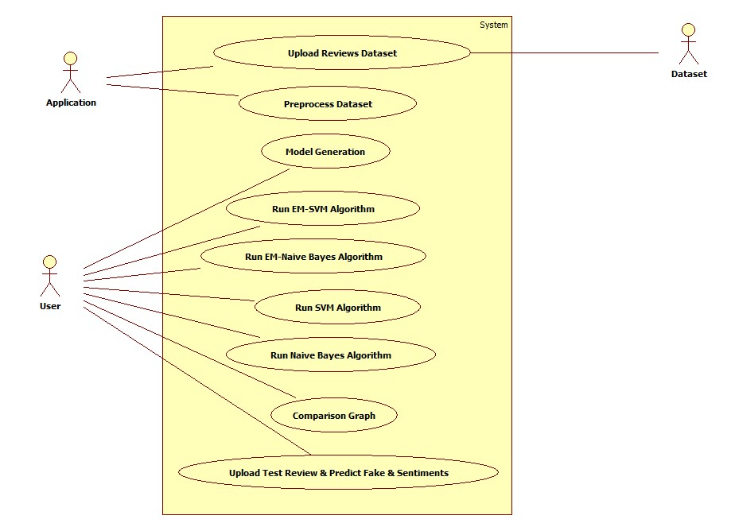

Figure: Use case Diagram

**Class diagram:**

The class diagram enhances both the use case diagram and the overall system design. The class diagram groups the actors found in the use case diagram into a number of similar classes. "Is-a" relationships and "has-a" relationships are the two kinds of relationships that could exist between the classes. Every class in the class diagram might be able to carry out specific tasks. These elements are referred to as the class's "methods". Furthermore, each class could have “attributes” that enable class differentiation.

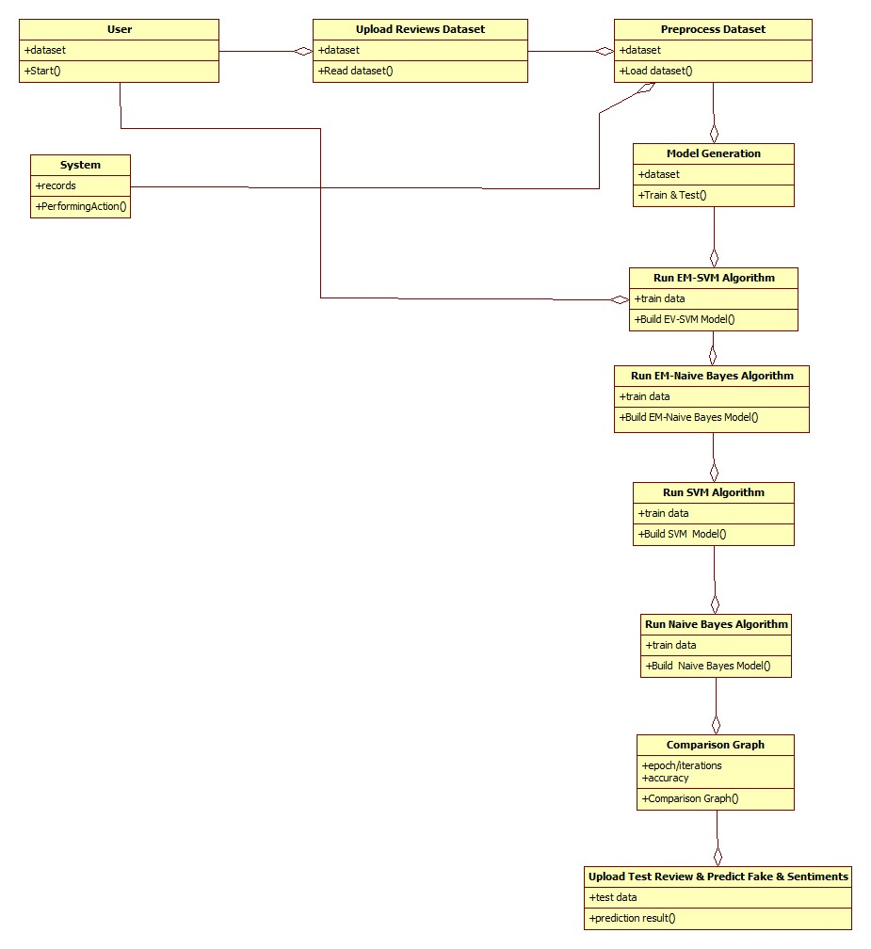

Figure: Class Diagram

**Deployment diagram:**

The deployment diagram depicts how the application's runtime components are arranged. It turns out to be especially helpful while assembling and preparing a system for deployment.A diagram of a company
Figure: Deployment Diagram

* **Analysis:**

The project proposal "SEMI-SUPERVISED AND SUPERVISED LEARNING METHODS FOR DETECTING FAKE ONLINE REVIEWS" offers a thorough strategy for addressing the issue of phony online reviews, which is becoming a rising concern. The project's impetus comes from the growing difficulty of telling real reviews from bogus ones, which presents a big problem for e-commerce businesses and service providers who depend on client feedback. The suggested approaches include supervised and semi-supervised classifications using methods like Support Vector Machines (SVM), Statistical Naive Bayes classifier, and Expectation-Maximization (EM).

The assessment metrics comprise a range of quantitative tests, such as learning curves, cross-validation, feature importance analysis, bias and fairness evaluation, and adversarial assault resistance. The project also highlights qualitative analysis using non-quantitative techniques like context analysis, user behaviour analysis, profiling, and pattern analysis. The plan provides a schedule and roles for each team member, guaranteeing a methodical and cooperative approach to project implementation. In general, the proposal presents a well-considered and comprehensive approach to tackle the intricate problem of fraudulent online reviews, incorporating quantitative and qualitative assessments to achieve a comprehensive knowledge and efficacious resolution.

* **Implementation:**

1. **Environment Setup:**

Assemble the required tools and libraries in the development environment. Installing Scikit-Learn, NumPy, Python, and any other libraries listed in the project prerequisites falls under this category.

1. **Data Preparation:**

Import the "Gold Standard" dataset, which includes reviews that are phony and authentic. Handle missing values, tokenize reviews, eliminate stop words and unnecessary characters, and convert the text into TF-IDF vectors as part of the dataset's preprocessing.

1. **Algorithm Implementation:**

Put the semi-supervised learning Expectation-Maximization (EM) algorithm into practice. This entails updating the classification of unlabelled data and iteratively estimating model parameters. Put the Support Vector Machine (SVM) supervised learning algorithm into practice. Taking the dataset's characteristics into consideration, modify the SVM settings for better results. Use the ease of use and effectiveness of the Naive Bayes algorithm for supervised learning in classification tasks. Put additional algorithms, including Random Forest and K-Nearest Neighbours (KNN), into practice while considering their unique use cases.

1. **Testing and Training:**

Divide the dataset into testing and training sets (e.g., 20% for testing and 80% for training). Utilizing suitable metrics like accuracy, precision, recall, and F1-score, train the implemented algorithms on the training set and assess their performance on the testing set.

1. **Evaluation and Optimization:** Examine the outcomes using metrics and comparison graphs to determine how successful each method is. Optimize the models and adjust hyperparameters to achieve higher performance.
2. **Testing Methodologies Implementation:**

Unit test each component separately to make sure it functions correctly. Test the data flow across the system to ensure that it is functioning properly. Integrate modules and carry out integration testing to confirm the system's dependability, performance, and functionality. Conduct user interface testing to find and fix any graphical user interface problems.

1. **Documentation:** Provide commentary and explanations for important functions and algorithms together with the implemented code. Offer comprehensive instructions on how to execute the code and duplicate the outcomes.
2. **Deployment:** If appropriate, use the trained models to make predictions in real time. Keep an eye on how well the deployed models are doing at all times, and frequently review their efficacy in changing online environments.
3. **Finalization:** Examine the implemented code and documentation in detail. Make sure that, while handling phony reviews, ethical principles and legal consequences are followed. Complete the project, noting the lessons that were learnt and possible directions for further development.

Software development best practices should be followed during the implementation phase to guarantee scalability, readability, and modularity of the code. To ensure the dependability and efficiency of the deployed algorithms in the identification of phony online reviews, regular testing and validation are essential.

* **Preliminary Results:**

Figure: Main Output Window

Above Desktop application is opened and click on Import Data.

## A screenshot of a computer Description automatically generated Figure: Import Dataset

Data is loaded into from the “Positive review” and “Negative Review” folder and it will print basic information of data.

## A screenshot of a computer Description automatically generated Figure: Data Preprocessing

* Now click on the Preprocess Button. Data frame is created, and we are converting target variable into four classes as below.
* Highly positive (1): The review is marked as positive and it is deceptive.
* Positive (2): A review is marked as positive and it is truly positive.
* Negative (3): A review is marked and negative and it is truly negative .
* Highly Negative (4): A review is marked and negative and it is deceptive.
* **Project Management:**

**Implementation Status Report:**

**Work Completed:**

**Explanation:**

With 70% of the project completed, "SEMI-SUPERVISED AND SUPERVISED LEARNING METHODS FOR DETECTING FAKE ONLINE REVIEWS," has accomplished a noteworthy milestone. The group has made great strides in tackling the problems posed by fraudulent internet reviews by effectively putting several of the suggested algorithms and testing techniques into practice. The "Gold Standard" dataset has been prepared for training and testing, and the development environment has been set up. Expectation-Maximization (EM), Support Vector Machine (SVM), Naive Bayes, K-Nearest Neighbour (KNN), and Random Forest algorithms are being implemented; this demonstrates the project's dedication to utilizing a wide range of machine learning methodologies.

**Accountability:**

1. Team Leader Rohitha Nagineni: In organizing the project, monitoring its general development, and making sure that tasks are completed on schedule, Rohitha has been instrumental. In her capacity as the team's leader, Rohitha has overseen organizing, coordinating, and ensuring that everyone in the team works together efficiently.
2. Sanjana Dadi, a specialist in deployment and communication: Sanjana is in charge of the project's deployment phase, making sure the trained models can be used successfully in situations that arise in real life. Furthermore, in her capacity as the communication specialist, Sanjana has been in charge of promoting efficient communication the team.
3. Data analyst Monish Galla: As the data analyst, Monish has taken over the responsibility and is carefully managing the "Gold Standard" dataset. He has been in charge of cleaning, tokenizing, and converting text into TF-IDF vectors as part of the data preparation process. The basis of the machine learning models has been greatly influenced by Monish's proficiency in data analysis.
4. Model tester and evaluator Shiva Sai Amaravadi: The vital task of assessing the models that have been put into practice has been assumed by Shiva Sai. He has actively participated in several testing methodologies, such as integration, data flow, and unit testing. The generated algorithms' dependability and usefulness are ensured by Shiva Sai's part.

**Members' Contributions:**

* Rohitha Nagineni:

Organizing group activities.

Assignment of tasks and supervision.

* Sanjana Dadi:

Planning and carrying out deployments.

Facilitating communication among team members.

* Monish Galla:

Data analysis and preparation.

Data processing algorithm implementation.

* Shiva Sai Amaravadi:

Testing and evaluating the models.

Participation in testing tactics.

**Work To Be Completed:**

**Explanation:**

The last 30% of the project will be devoted to completing the implementation, carrying out exhaustive testing, and making sure the machine learning models for identifying phony online reviews are solid. We found some data leakage problems in my project, which might be causing the high accuracy. We will address and fix these data leakage issues in the project's next final submission to guarantee correct findings. This stage entails optimizing algorithms, carrying out further testing techniques, recording the implementation procedure, and resolving any unresolved problems. The objective is to have an optimized, fully working system that is prepared for deployment.

**Accountability:**

1. **Algorithm Fine-Tuning:**

**Team Member:**

**Task:** Optimize performance and improve accuracy by fine-tuning the implemented algorithms, such as EM, SVM, Naive Bayes, KNN, and Random Forest.

1. **Code Comments and Documentation:**

**Team Member: Monish Galla**

**Task:** Provide a thorough documentation of the implemented code, with comments and explanations for all major algorithms and functions. Make sure the documentation is easy to read and retain for future use.

1. **Thorough Testing:**

**Shiva Sai Amaravadi (Model Evaluator and Tester):**

**Task:** To guarantee the dependability and robustness of the machine learning models, conduct comprehensive testing, incorporating extra testing scenarios and edge cases.

1. **User Interface Testing:**

**Deployment and Communication Specialist Sanjana Dadi):**

**Task:** To find and fix any problems with the graphical user interface, test the user interface. Make sure the user experience is flawless.

1. **Complete Review and Optimization:**

**Team Leader Rohitha Nagineni:**

**Task:** Undertake a comprehensive project evaluation to guarantee compliance with ethical standards, legal implications, and optimal outcomes. In charge of any required optimization initiatives.

**Problems/challenges:**

1. Optimization Challenges: Optimizing performance and fine-tuning algorithms can be difficult tasks. The group must work together to resolve any problems pertaining to algorithmic accuracy and efficiency.
2. Integration Testing Complexity: - Complexities might arise during integration testing, especially when integrating different methodologies. The group ought to take the initiative to resolve any issues arising from the amalgamation of distinct elements.
3. Documentation Consistency: - It can be difficult to guarantee thorough and consistent documentation. To preserve consistency in the documentation of the implementation, the team must cooperate.
4. Deployment Considerations: - To guarantee a smooth integration with real-time data, the deployment procedure needs to be well thought out. Any issues pertaining to the deployment phase should be directed onto Sanjana Dadi, the deployment specialist.
5. Model Robustness: - It is imperative to guarantee that the models are resilient to real-world situations and possible adversarial attacks. The group's primary goal should be to test the models in dynamic online environments.

By addressing these problems and finishing the remaining tasks, the project will be successfully completed and offer a dependable and practical method for identifying phony online reviews

**REFERENCES**

1. Chengai Sun, Qiaolin Du and Gang Tian, “Exploiting Product Related Review Features for Fake Review Detection,” Mathematical Problems in Engineering, 2019.
2. A. Heydari, M. A. Tavakoli, N. Salim, and Z. Heydari, “Detection of review spam: a survey”, Expert Systems with Applications, vol. 42, no. 7, pp. 3634–3642, 2019.

3.M. Ott, Y. Choi, C. Cardie, and J. T. Hancock, “Finding deceptive opinion spam by any stretch of the imagination,” in Proceedings of the 49th Annual Meeting of the Association for Computational Linguistics: Human Language Technologies (ACL- HLT), vol. 1, pp. 309–319, Association for Computational Linguistics, Portland, Ore, USA, June 2020.

4.J. W. Pennebaker, M. E. Francis, and R. J. Booth, ”Linguistic Inquiry and Word Count: Liwc,” vol. 71, 2018.

1. S. Feng, R. Banerjee, and Y. Choi, “Syntactic stylometry for deception detection,” in Proceedings of the 50th Annual Meeting of the Association for Computational Linguistics: Short Papers, Vol. 2, 2019.